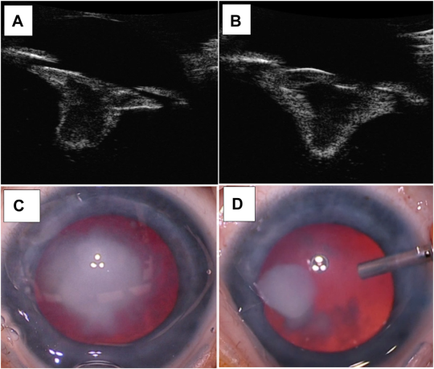

A 3-month-old girl with mild brachycephaly and a broad nasal bridge was referred for cataract surgery. She had hearing loss in her leftear, an atrial septal defect, and a pulmonary venous anomaly. Initial examination showed blink-to-light vision without nystagmus orstrabismus. Examination under anesthesia found bilateral cataracts with posterior lentiglobus (A, B, C). Infusion flushed the cataract outintraoperatively (D). Genetic testing showed a heterozygous variant (c.799_802del) in USP9X, on the X-chromosome. Based on the provided images and clinical description please make an ophthalmic diagnosis for this patient. And output the diagnostic conclusions only.

**Bilateral congenital cataracts and posterior lentiglobus associated with USP9X variant.**